Name: Mohammad Yehya Hayati

Roll Number: K213309

Section: BCS-4F

Semester: Spring 2023

The code is given on Google Classroom, however in case it wasn’t sent properly, as a precaution here is the code attached below.



Here is the compilation and execution of the code:

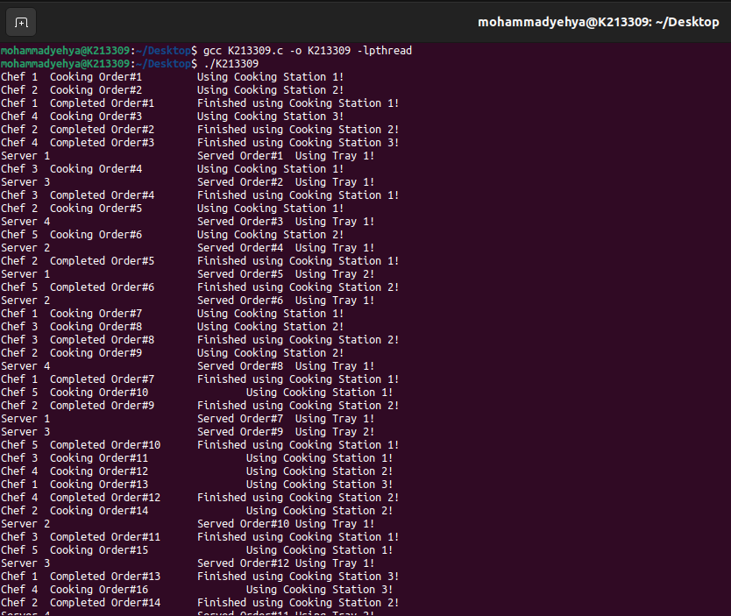

As you can see that there are only 5 chefs, 3 stations, 4 servers, 2 trays (configurable MACROS defined in the code). No stations are being used at the same time and no trays are being used at the same time.